DIY Craft Triangle Robot

Building steps



Scan the above QR code to subscribe to our channel and get the latest updates.

What you get in the kit?

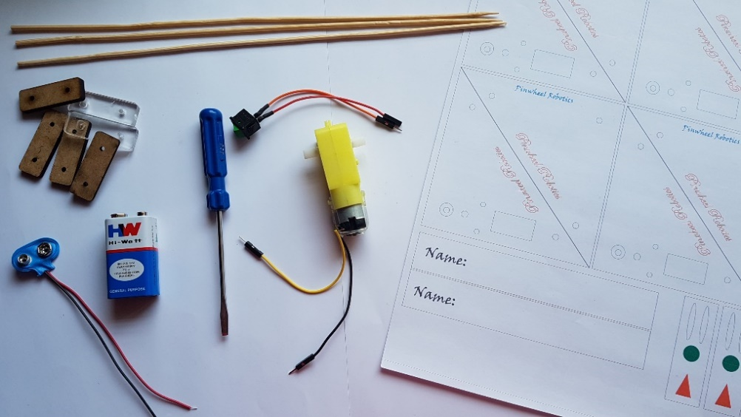

1. Sticker paper to make two triangle robot.
2. 9V Zinc-carbon battery
3. Battery clip
4. Dual shaft motor
5. On Off switch
6. Screw driver
7. Motor screws
8. Pinwheel hinge pieces
9. Skewers

What you need to build

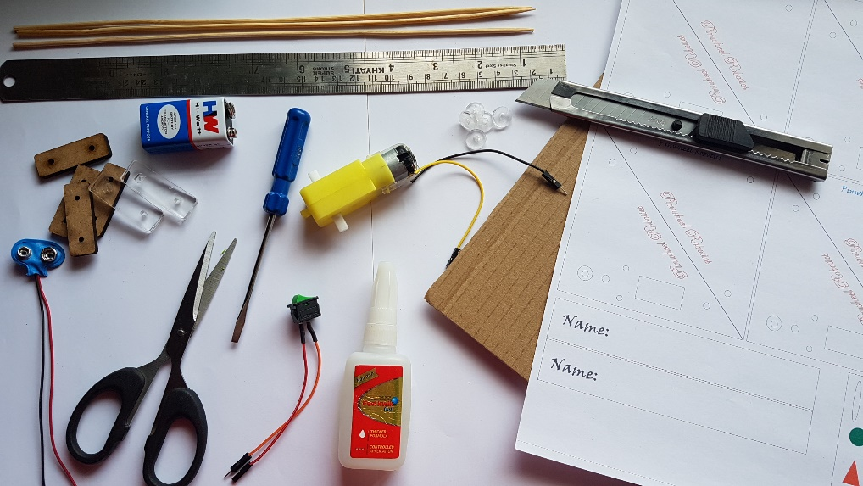

Apart from what is provided in your kit you would need following to build your robot:

1. Cardboard/ firm board
2. Super glue/ fevicol / hot glue
3. Glue gun stick plugs
4. Paper knife cutter
5. Scissors
6. Scale

Step 1:

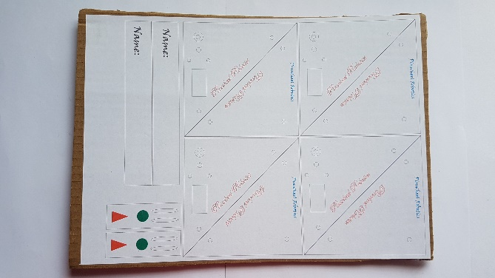

Stick the sticker paper over cardboard

Step 2:

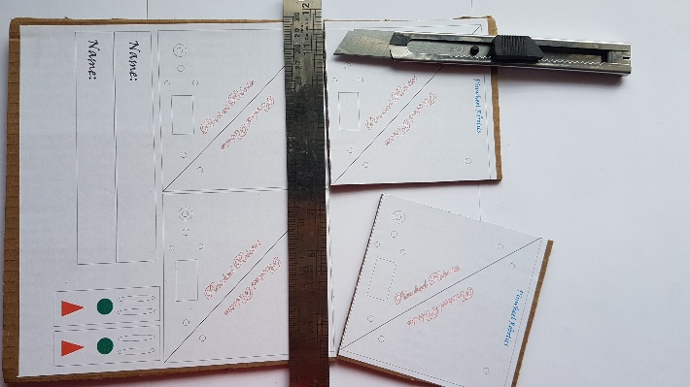

Cut the cardboard using the sticker reference lines

Step 3:

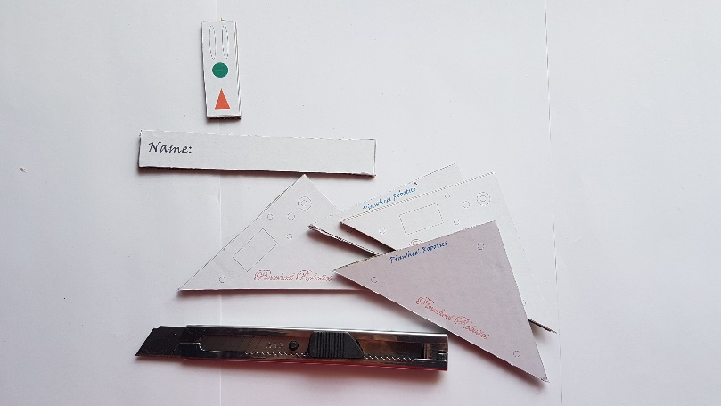

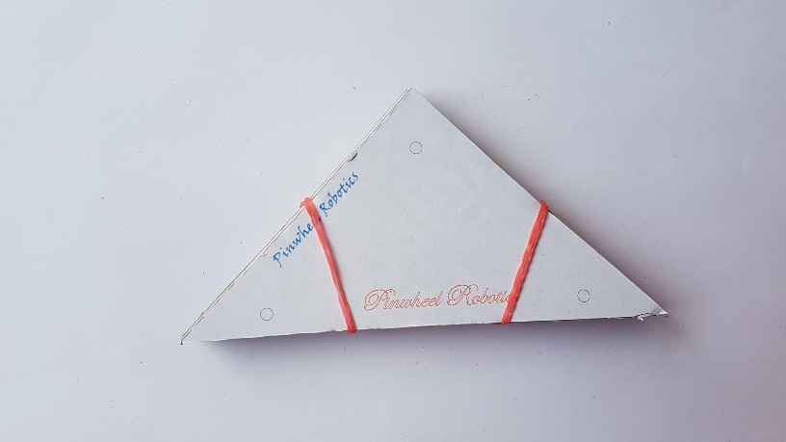

Hold the 4 triangle pieces together by securing it with rubber bands or masking tape.

Step 4:

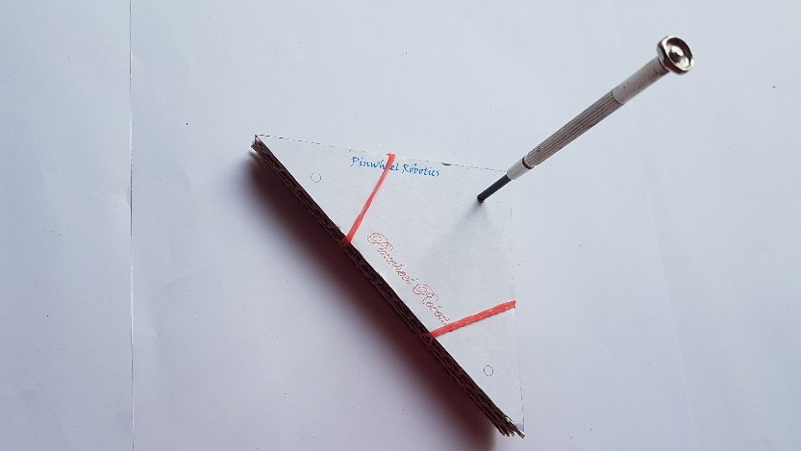

Using a pointed object (screw driver) make holes on all 4 pieces together so that you get holes in same position on all your triangle pieces.

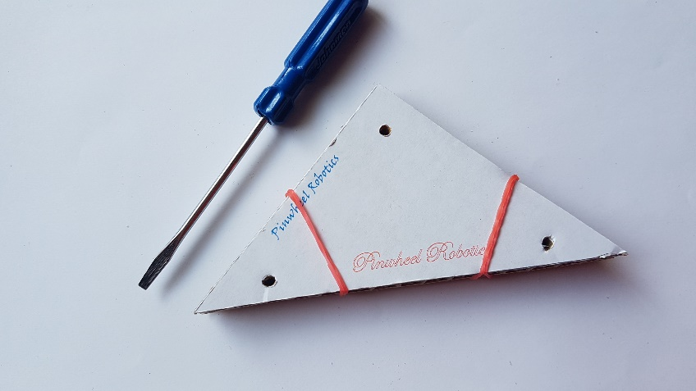

Step 5:

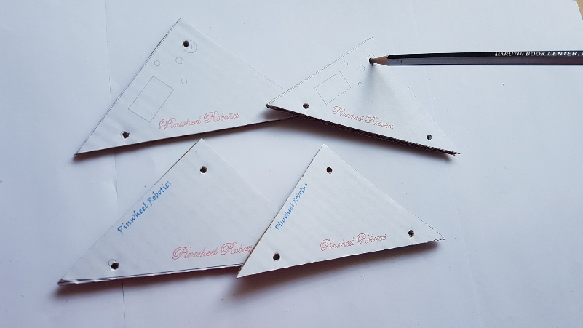

Make a bigger hole in 2 triangle pieces marked with motor design using a pencil.

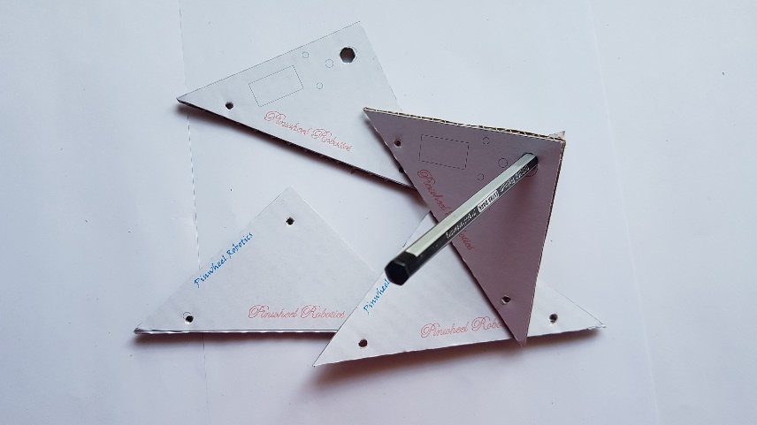

Step 6:

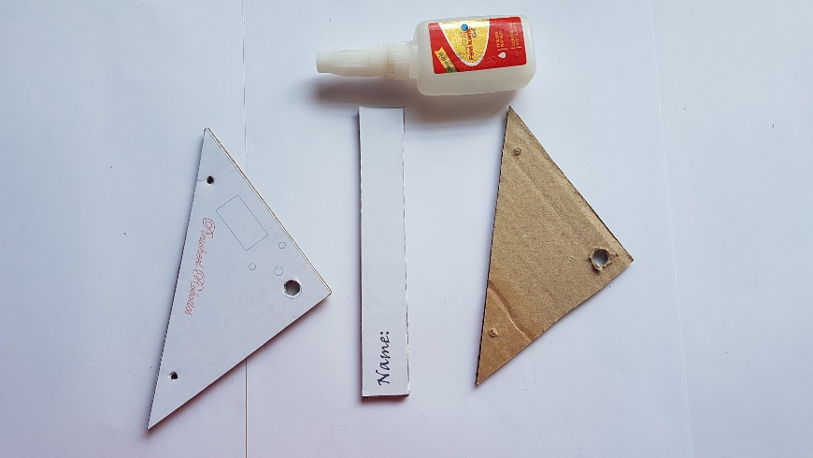

Using strong glue stick the two motor triangle piece to stick on the two side of the base piece.

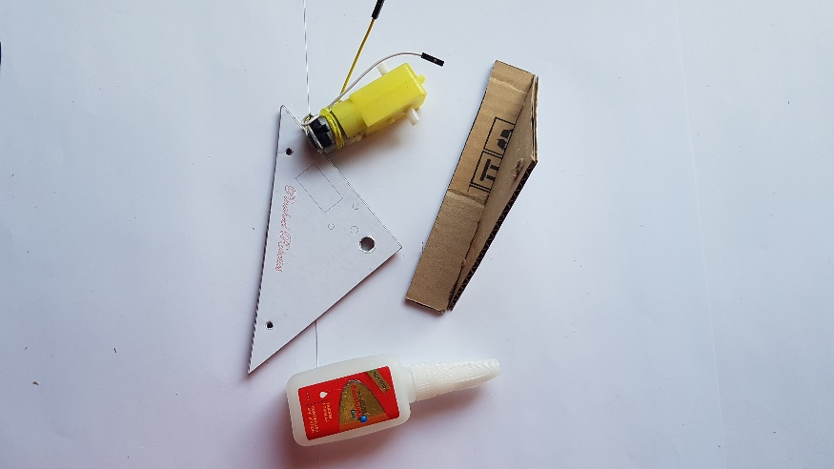

Step 7:

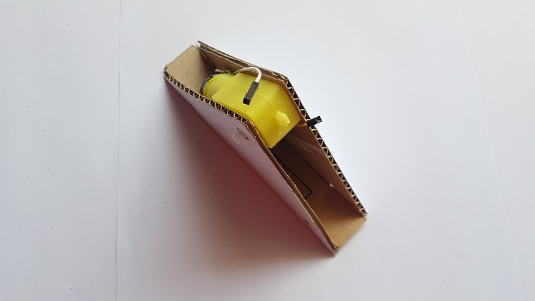

Stick the motor with double sided tape or glue, between the two triangle pieces with it shaft passing through the big holes made in step 5.

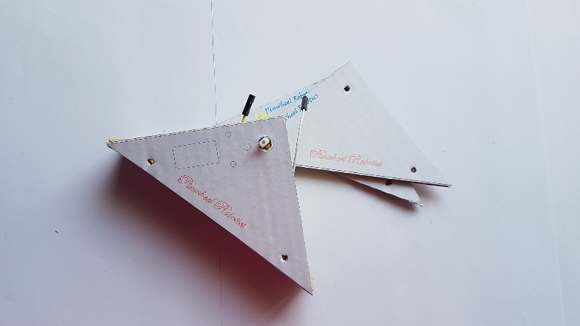

Step 8:

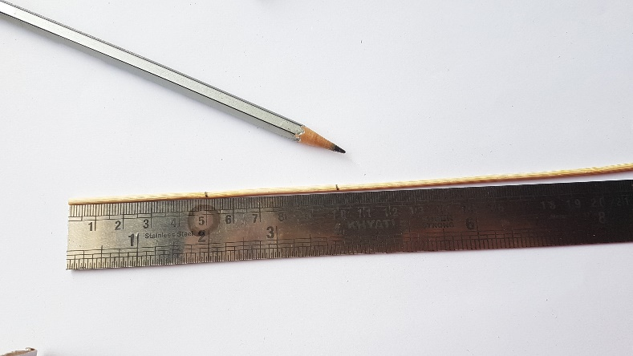

Using a scale cut two 5cm wooden skewer pieces

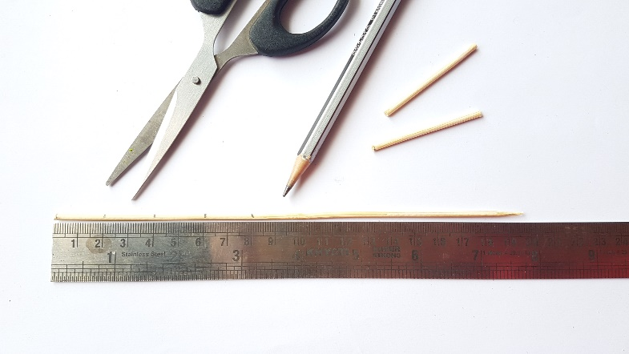

Also cut 6 pieces of wooden skewer of 2cm each

Step 9:

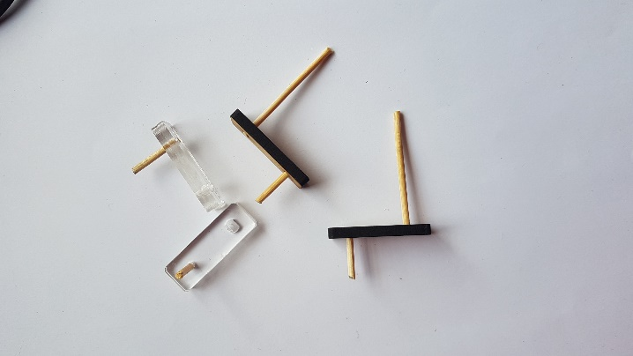

Insert the cut skewer pieces on the hinges as shown (only one skewer piece of 2cm on acrylic hinge)

Step 10:

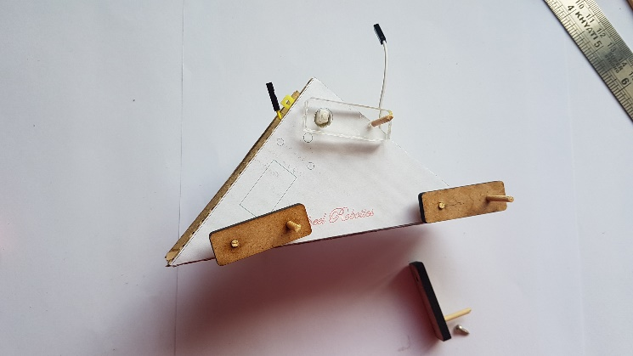

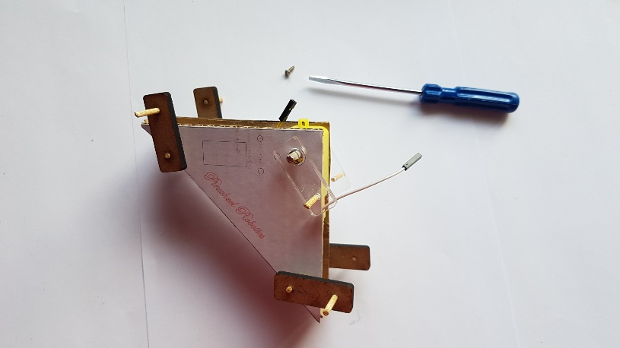

Fix the acrylic piece on the motor shaft and secure it with the motor screw.

The wooden hinge with 5cm skewer through the two remaining holes as shown.

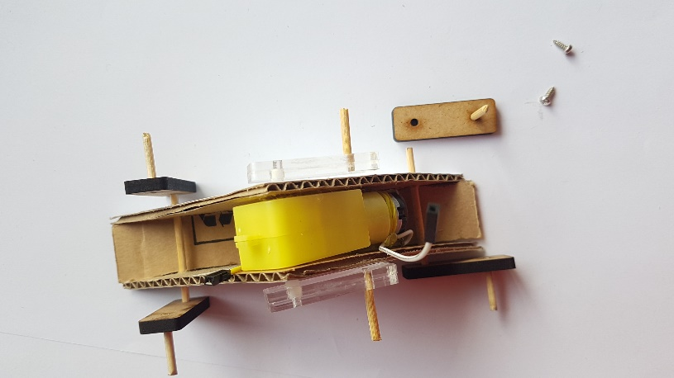

Step 11:

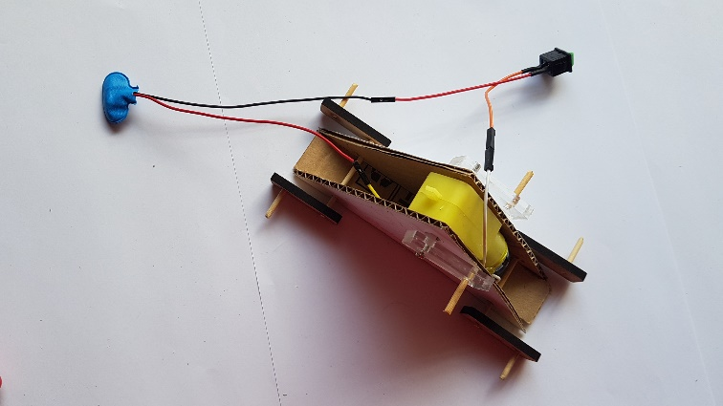

Connect the motor through battery clip and switch to make a circuit.

Step 12:

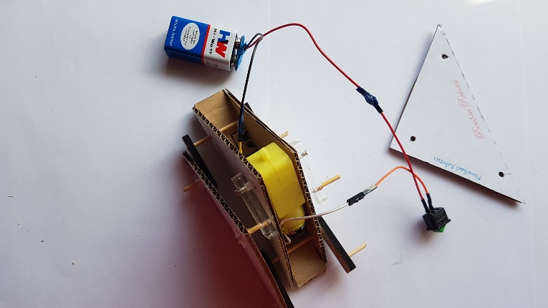

Insert the remaining triangle piece to the protruding skewer pieces and secure it with the glue gun stick plug piece.

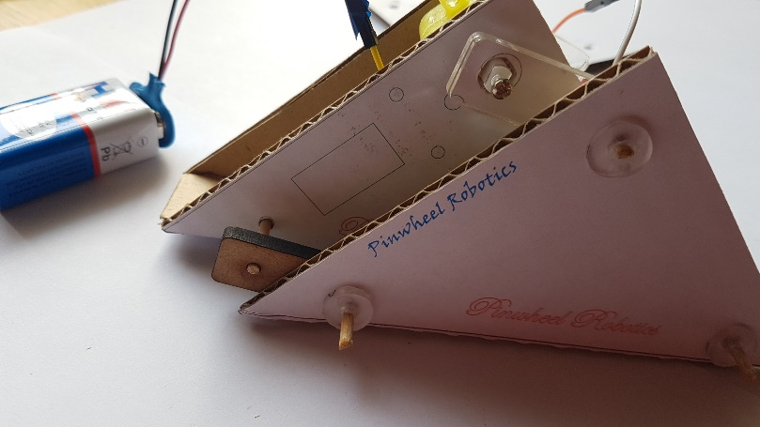

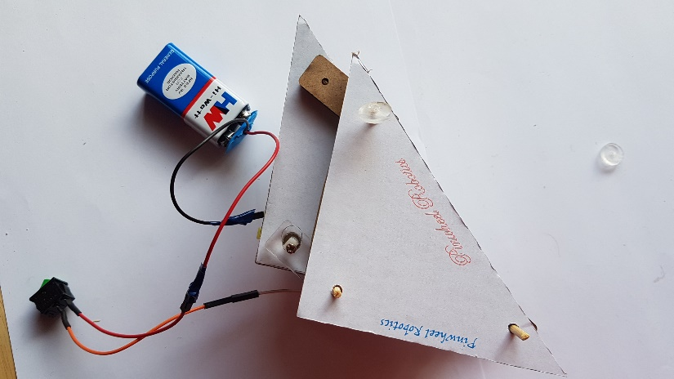

Step 13:

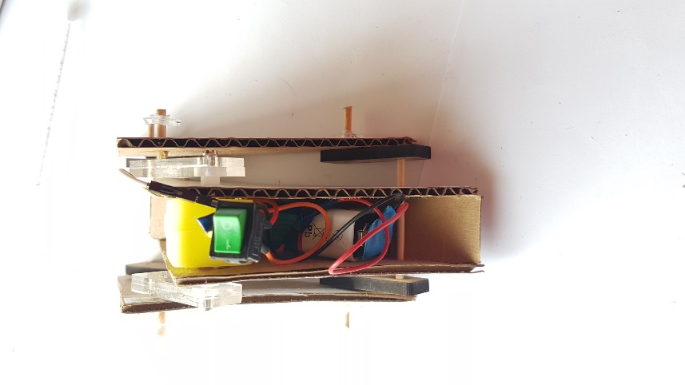

Stuff the battery and all the connecting wires inside the robot body.

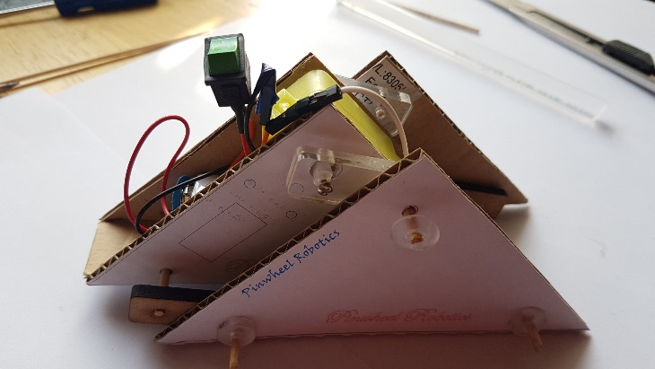

The final assembly should look like above.

Step 14:

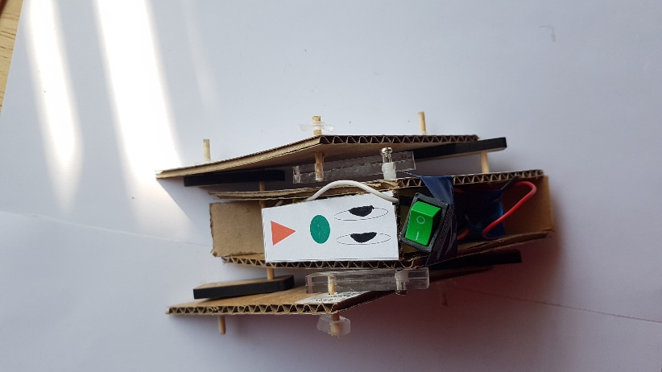

Stick the animal face piece or any face decoration piece of your choice, on one side of the triangle robot.

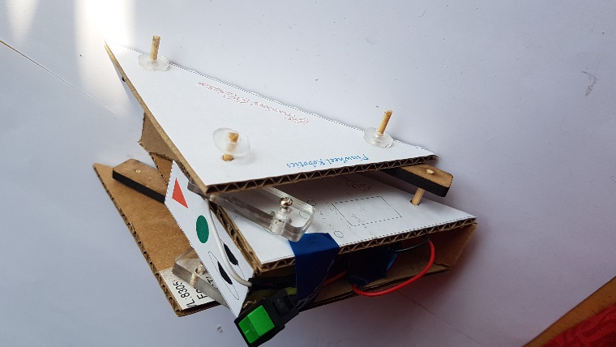

Your personal robotic animal is ready to play! Enjoy!